**To Supply Leftover Food To Poor**

**College Name : Sree Ramu College Of Arts and Science**

**College Code : bru3k**

**Team ID :** NM2025TMID28644

**Team Members:**

* Team leader : Vishalini N

Email :[vishavisha1782006@gmail.com](mailto:vishavisha1782006@gmail.com)

* Team Member 1 : Vellaisamy S

Email : [vellaisamycssrc@gmail.com](mailto:vellaisamycssrc@gmail.com)

* Team Member 2 : Pragatheesh K

Email : [pragatheeshcssrc@gmail.com](mailto:pragatheeshcssrc@gmail.com)

* Team Member 3 : Omprakash M

Email : [omprakashcssrc@gmail.com](mailto:omprakashcssrc@gmail.com)

**Project Overview**

Every day, a huge quantity of food is wasted at restaurants, hotels, events, and households, while many people go to sleep hungry. This project aims to create a sustainable system for collecting safe leftover food and distributing it to underprivileged communities.

**Objectives**

* To minimize food wastage by collecting safe and edible leftover food from hostels, hotels, canteens, and events.
* To provide nutritious meals to poor and needy people who struggle to get daily food.
* To establish a systematic process for food collection, storage, and distribution in a hygienic manner.
* To create awareness among students and the public about the importance of reducing food waste.
* To build partnerships with NGOs, local communities, and volunteers for sustainable food supply.
* To promote social responsibility among students by encouraging them to contribute their time and effort.
* To design a monitoring system (manual/app-based) to track the food donors and beneficiaries.

**Student Outcomes**

* **Social Responsibility –** Students develop empathy and awareness towards hunger and food wastage in society**.**
* **Problem-Solving Skills –** Learn to plan collection, storage, and distribution of food efficiently**.**
* **Teamwork & Collaboration –** Work in groups to coordinate with restaurants, hostels, canteens, and NGOs
* **Leadership Qualities –** Take initiative in organizing food drives and managing resources**.**
* **Communication Skills –** Improve by interacting with food donors, volunteers, and beneficiaries**.**
* **Project Management –** Gain experience in scheduling, logistics, and monitoring food distribution**.**
* **Innovation & Creativity –** Think of smart solutions (apps, networks, tracking systems) to reduce food waste**.**
* **Ethical & Value Education –** Understand the importance of sharing, caring, and sustainable living**.**
* **Community Engagement –** Build strong connections with society by serving the needy.
* **Personal Growth –** Develop kindness, patience, and gratitude while helping others.

**System Requirements**

Hardware Requirements:

* Computer with min/sum 4 GB RAM, Dual-core processor
* Stable internet connection

Software Requirements:

* Salesforce Developer Edition Org
* Modern Web Browser (e.g., Google Chrome, Firefox)

**To Supply Leftover Food to Poor**

Utilizing Salesforce, our project streamlines surplus food collection and distribution to the needy, ensuring efficiency and transparency.

### Milestone 1 : Salesforce developer account creation

### Activity 1 : Creating Developer Account

Creating a developer org in salesforce.

1. Go to <https://developer.salesforce.com/signup>
2. On the sign up form, enter the following details : [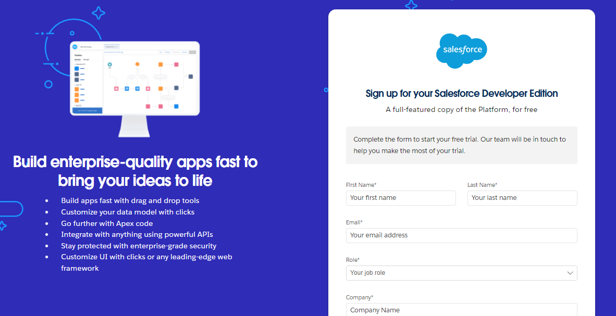](https://developers.salesforce.com/Signup*)
   1. First name & Last name
   2. Email
   3. Role : Developer
   4. Company : College or Company Name
   5. County : India
   6. Postal Code : pin code
   7. Username : should be a combination of your name and company

This need not be an actual email id, you can give anything in the format :

username@organization.com

Click on sign me up after filling these.

**Activity 2 : Account Activation**

1. Go to the inbox of the email that you used while signing up. Click on the verify account to activate your account. The email may take 5-10mins.

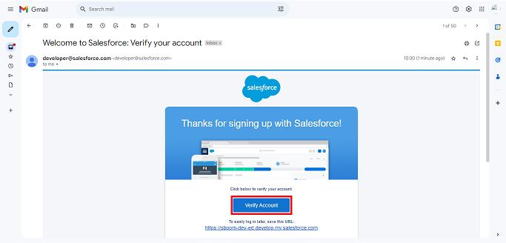

1. 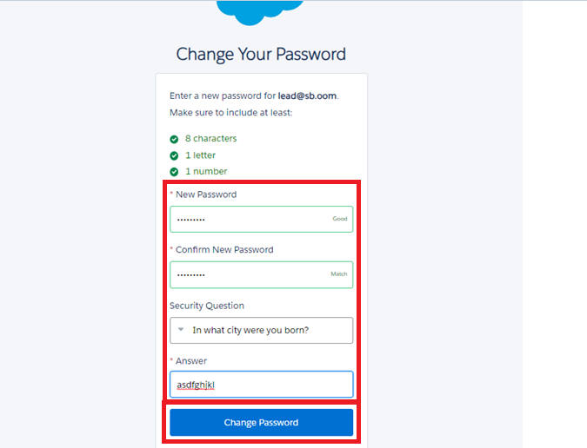Click on Verify Account
2. Give a password and answer a security question and click on change password.

1. Give a password and answer a security question and click on change password.
2. Then you will redirect to your salesforce setup page.

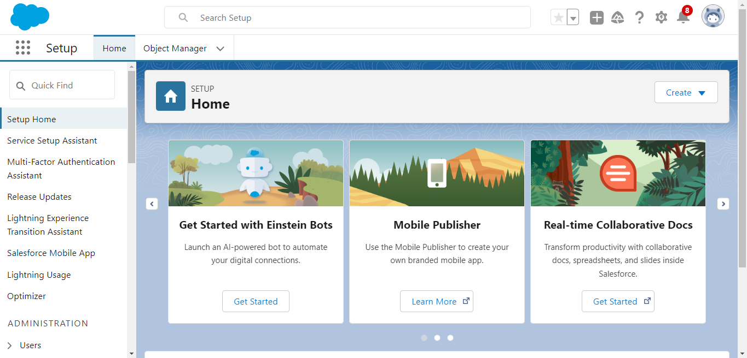

**Milestone 2 : Object**

To Navigate to Setup page:

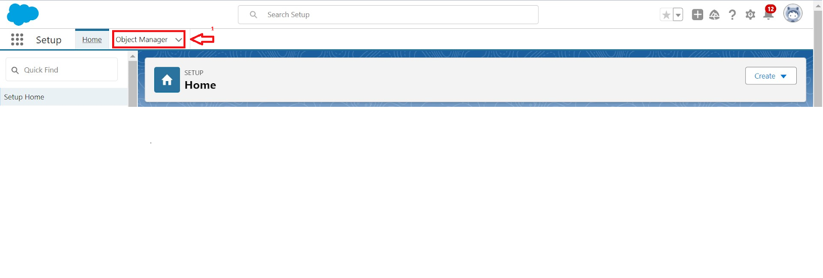

To create an object:

1. From the setup page > Click on Object Manager > Click on Create > Click on Custom Object.

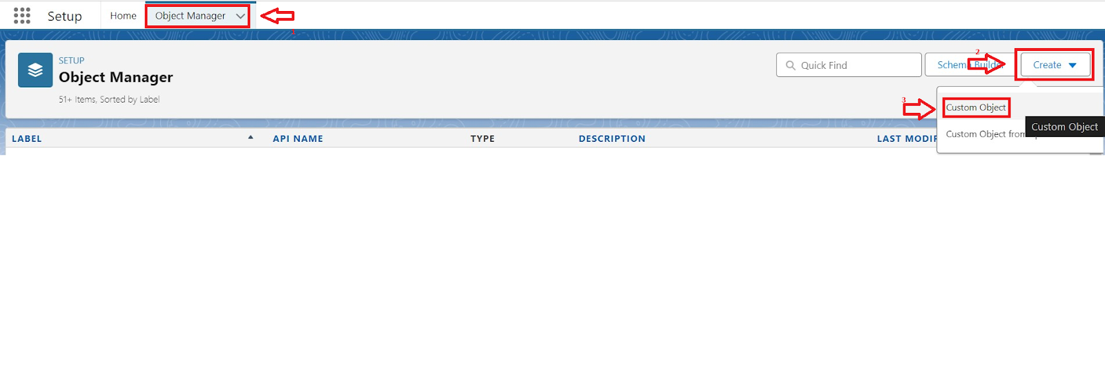

1. On Custom object defining page:
2. Enter the label name, plural label name, click on Allow reports, Allow search.

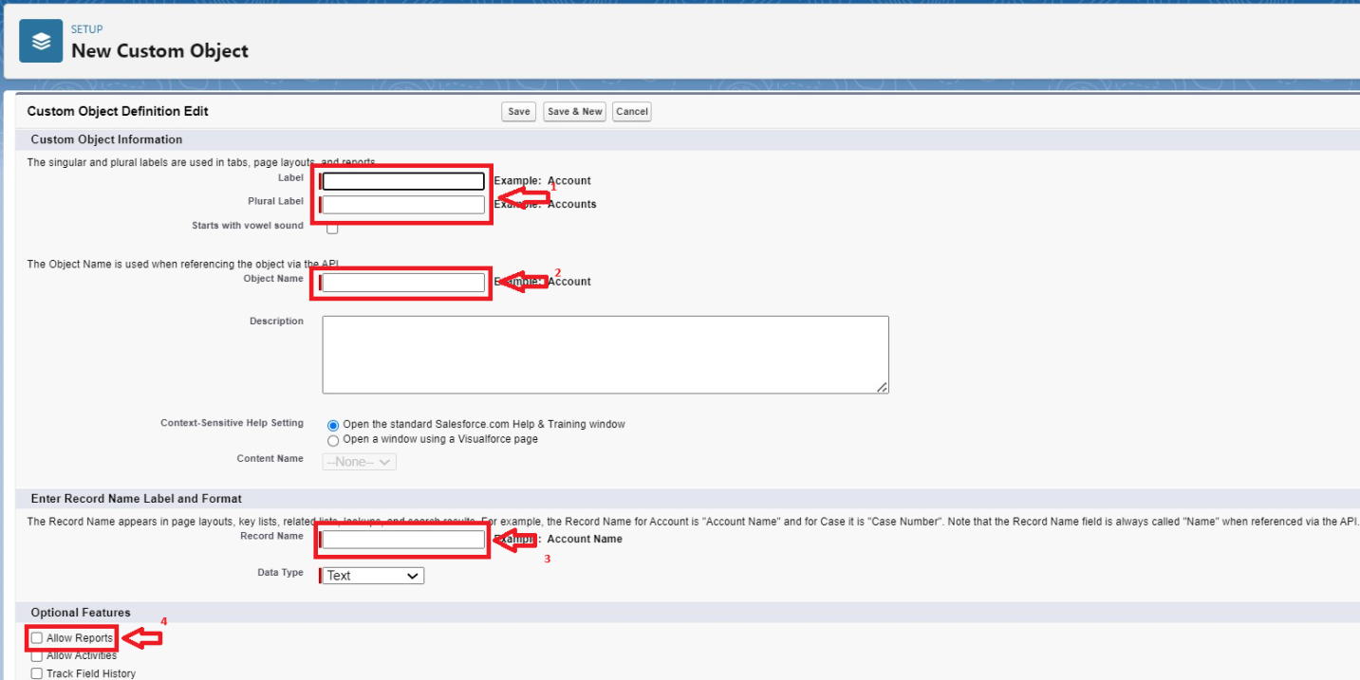

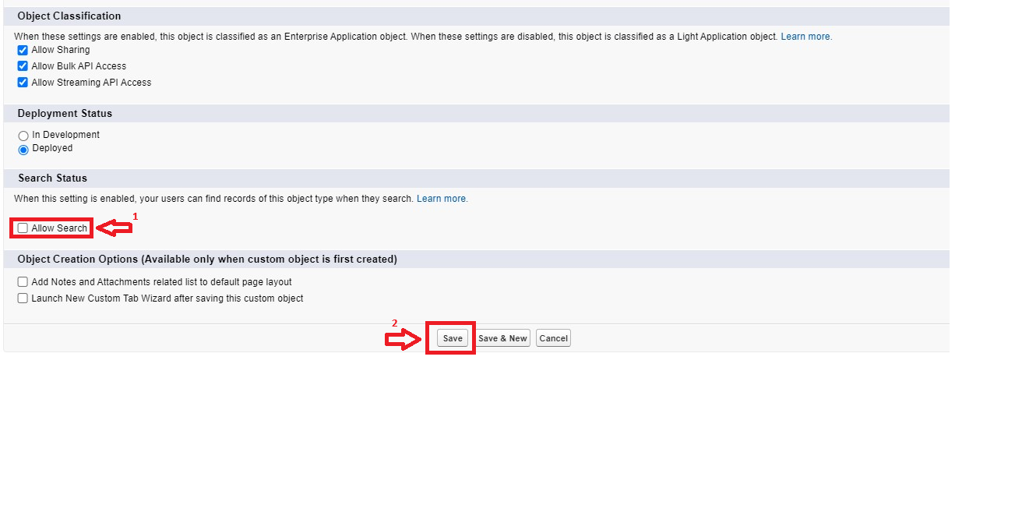

1. Click on Save.

### Activity 1 : Create Venue Object

To create an object:

1. From the setup page >> Click on Object Manager >> Click on Create >>Click on Custom Object.
2. Enter the label name >> Venue
3. Plural label name >> Venues
4. Enter Record Name Label and Format

* Record Name >> Venue Name
* Data Type >> Text

1. Click on Allow reports and Track Field History,Allow Activities.
2. Allow search >> Save.

### Activity 2 : Create Drop-Off Point Object

To create an object:

1. From the setup page >> Click on Object Manager >> Click on Create >> Click on Custom Object.
2. Enter the label name >> Drop-Off Point
3. Plural label name>> Drop-Off Points
4. Enter Record Name Label and Format

* Record Name >> Drop-Off point Name
* Data Type >> Text

1. Click on Allow reports and Track Field History,Allow Activities
2. Allow search >> Save.

### Activity 3 : Create Task Object

To create an object:

1. From the setup page >> Click on Object Manager >> Click on Create >> Click on Custom Object.
2. Enter the label name>> Task
3. Plural label name>> Tasks
4. Enter Record Name Label and Format

* Record Name >> Task Name
* Data Type >> Text

1. Click on Allow reports and Track Field History,Allow Activities
2. Allow search >> Save.

### Activity 4 : Create Volunteer Object

To create an object:

1. From the setup page >> Click on Object Manager>> Click on Create >> Click on Custom Object.
2. Enter the label name>> Volunteer
3. Plural label name>> Volunteers
4. Enter Record Name Label and Format

* Record Name >> Volunteer Name
* Data Type >> Text

1. Click on Allow reports and Track Field History, Allow Activities
2. Allow search >> Save.

### Activity 5 : Create Execution Details Object

To create an object:

1. From the setup page >> Click on Object Manager >> Click on Create >> Click on Custom Object.
2. Enter the label name >> Execution Detail
3. Plural label name >> Execution Details
4. Enter Record Name Label and Format

* Record Name >> Execution Detail Name
* Data Type >> Text

1. Click on Allow reports and Track Field History, Allow Activities
2. Allow search >> Save.

### Milestone 3 : Tabs

What is Tab : A tab is like a user interface that is used to build records for objects and to view the records in the objects.

**Activity 1 : Creating a Custom Tab**

To create a Tab:(Venue)

1. Go to setup page >> type Tabs in Quick Find bar >> click on tabs >> New (under custom object tab)

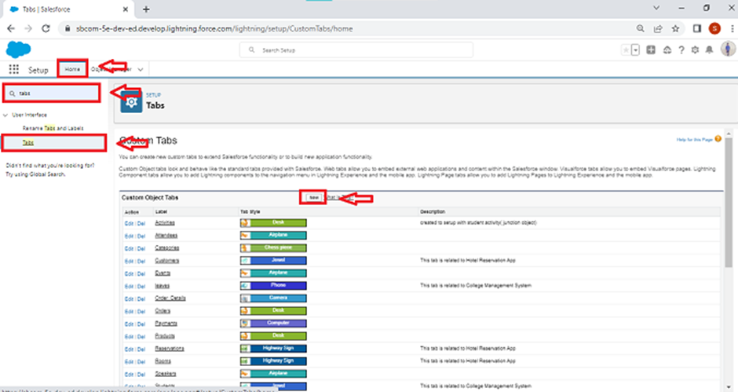

1. Select Object(Venue) >> Select the tab style >> Next (Add to profiles page) keep it as default >> Next (Add to Custom App)  uncheck the include tab .
2. Make sure that the Append tab to users' existing personal customizations is checked.
3. Click save

### Activity 2 : Creating Remaining Tabs

1. Now create the Tabs for the remaining Objects, they are “Drop-Off Point, Task, Volunteer, Execution Details”.
2. Follow the same steps as mentioned in Activity -1 .

### Milestone 4 : The Lightning App

### Activity 1 : Create a Lightning App

**To create a lightning app page:**

1. Go to setup page >> search “app manager” in quick find >> select “app manager” >> click on New lightning App.

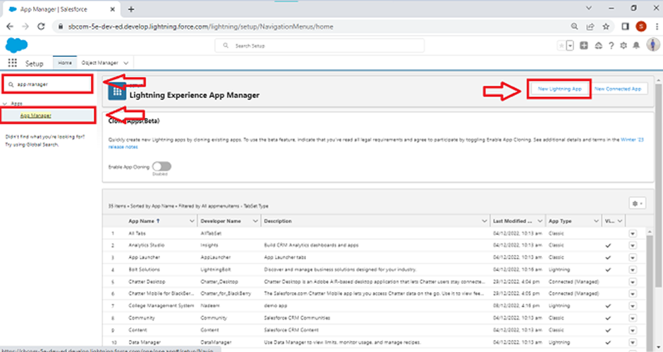

2. Fill the app name in app details and branding as follow  
App Name : FoodConnect  
Developer Name : This will auto populated  
Image : optional (if you want to give any image you can otherwise not mandatory) Primary color hex value : keep this default.

3.Then click Next  >> (App option page)Set Navigation Style as Standard Navigation >> Next.

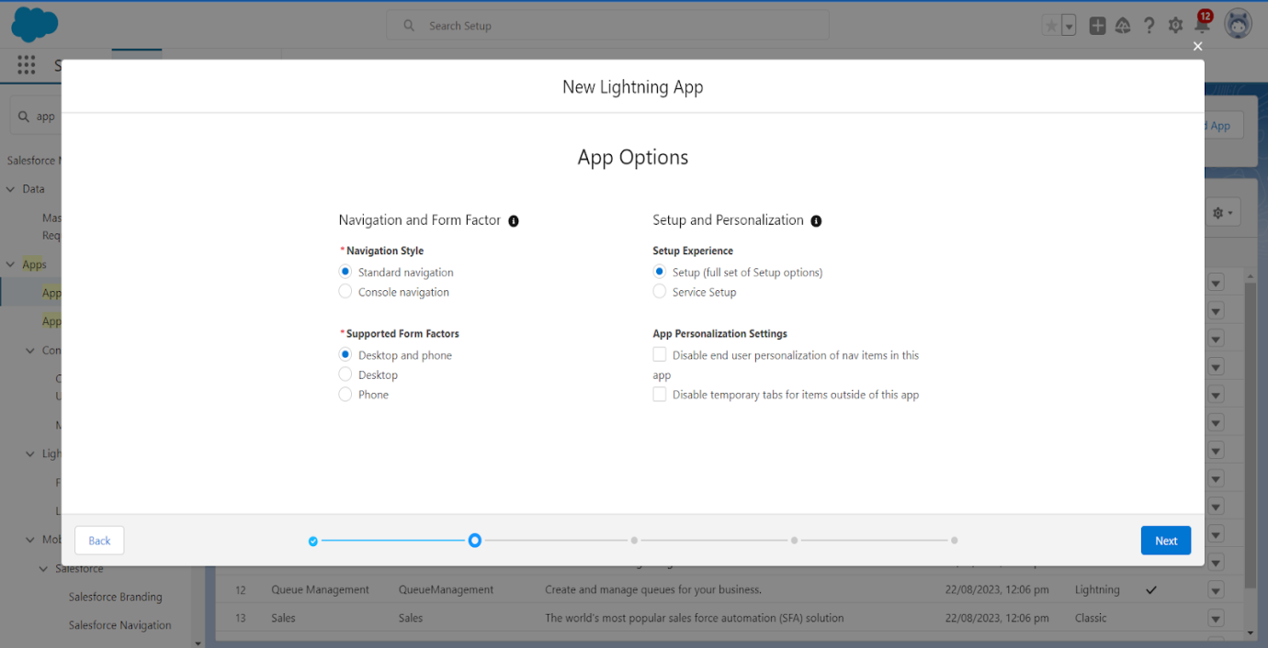

4. (Utility Items) keep it as default >> Next.  
5. To Add Navigation Items:

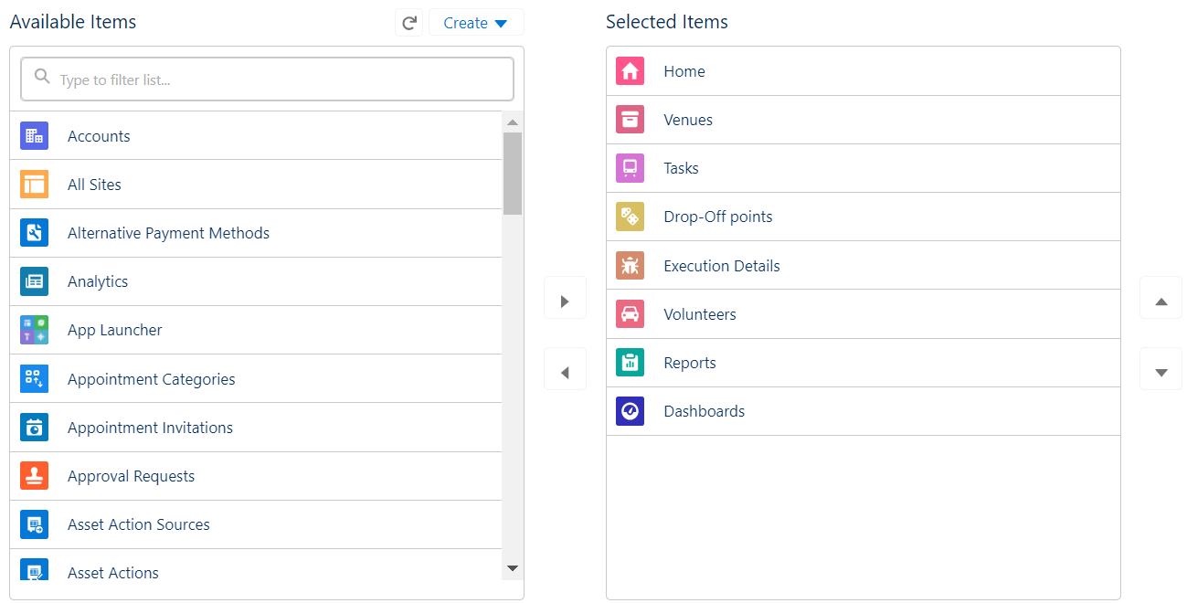

Search for the item in the (Home, Venue, Drop-Off Point, Task, Volunteer, Execution Details, Reports) from the search bar and move it using the arrow button >> Next >> Next.

6. To Add User Profiles:

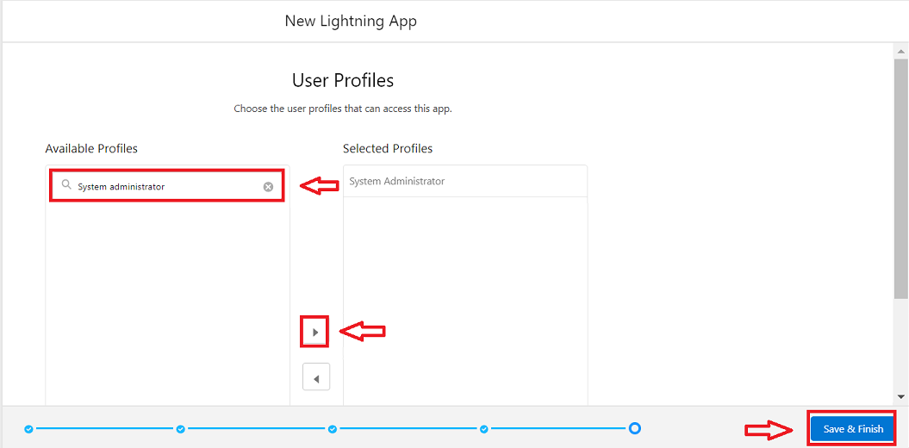

Search profiles (System administrator) in the search bar >> click on the arrow button >> save & finish.

### Milestone 5 : Fields

Activity 1 : **Creation of Relationship fields in objects**

**Creation of Lookup Relationship Field on Volunteer Object :**

1. Go to setup >> click on Object Manager >> type object name(Volunteer) in the search  bar >> click on the object.

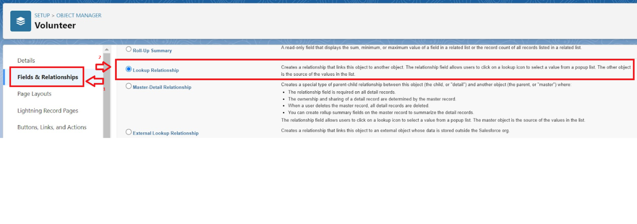

1. Now click on “Fields & Relationships” >> New
2. Select Master Detail relationship
3. Select the related object “Drop-Off point” and click next.

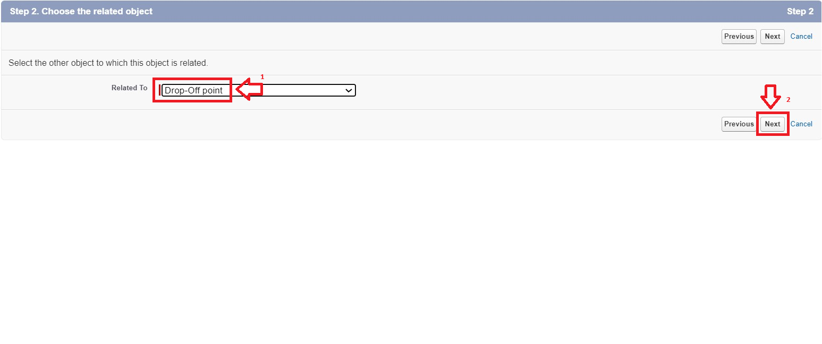

1. Field Name : Drop_Off_point
2. Field label : Auto generated
3. Next >> Next >> Save.

**Creation of Master Detail Relationship Field on Execution Details Object :**

1. Go to setup >> click on Object Manager >> type object name(Execution Details) in the search  bar >> click on the object.
2. Now click on “Fields & Relationships” >> New
3. Select Master Detail relationship
4. Select the related object “Volunteer” and click next.
5. Field Name : Volunteer
6. Field label : Auto generated
7. Next >> Next >> Save.

Creation of Master Detail Relationship Field on Execution Details Object :

1. Go to setup >> click on Object Manager >> type object name(Execution Details) in the search  bar >> click on the object.
2. Now click on “Fields & Relationships” >> New
3. Select Master Detail relationship
4. Select the related object “Task” and click next.
5. Field Name : Task
6. Field label : Auto generated
7. Next >> Next >> Save.

Creation of Lookup Relationship Field on Drop-Off Point Object :

1. Go to setup >> click on Object Manager >> type object name(Drop-Off Point) in the search  bar >> click on the object.
2. Now click on “Fields & Relationships” >> New
3. Select Lookup relationship
4. Select the related object “Venue” and click next.
5. Field Name : Venue
6. Field label : Venue__c
7. Next >> Next >> Save.

Creation of Lookup Relationship Field on Task Object :

1. Go to setup>> click on Object Manager >> type object name(Task) in the search  bar >> click on the object.
2. Now click on “Fields & Relationships” >> New
3. Select Lookup relationship
4. Select the related object “Venue” and click next.
5. Field Name : Sponsored By
6. Field label : Auto generated
7. Next >> Next >> Save.

Creation of Lookup Relationship Field on Task Object :

1. Go to setup>> click on Object Manager >> type object name(Task) in the search  bar >> click on the object.
2. Now click on “Fields & Relationships” >> New
3. Select Lookup relationship
4. Select the related object “Drop-Off point” and click next.
5. Field Name : Drop-Off point
6. Field label : Auto generated
7. Next >> Next >> Save.

**Activity 2 : Creation of fields for the Venue object**

1. Go to setup>> click on Object Manager >> type object name(Venue) in search bar >> click on the object.
2. Now click on “Fields & Relationships” >> New
3. Select Data type as a “Email” and Click on Next
4. Fill the Above as following:

* Field Label : Contact Email
* Field Name : Contact Email
* Click on required check box
* Click on Next >> Next >> Save and new.

**To create another fields in an object:**

1. Go to setup >> click on Object Manager >> type object name(Venue) in search bar >> click on the object.
2. Now click on “Fields & Relationships” >> New
3. Select Data type as a “Phone” and Click on Next
4. Fill the Above as following:

* Field Label : Contact Phone
* Field Name : Contact Phone
* Click on required check box
* Click on Next >> Next >> Save and new.

**To create another fields in an object:**

1. Go to setup >> click on Object Manager >> type object name(Venue) in search bar >>click on the object.
2. Now click on “Fields & Relationships” >> New
3. Select Data type as a “Geolocation” and Click on Next
4. Fill the Above as following:

* Field Label : Location
* Decimal Places : 4
* Field Name : Location
* Description : Enter the Geolocation of your Venue
* Click on Next >> Next >> Save and new.

To create another fields in an object:

1. Go to setup >> click on Object Manager >> type object name(Venue) in search bar >> click on the object.
2. Now click on “Fields & Relationships” >> New
3. Select Data type as a “Long Text Area” and Click on Next
4. Fill the Above as following:

* Field Label : Venue Location
* Field Name : Venue_Location
* Click on Next >> Next >> Save and new.

**Activity 3 : Creation of fields for the Drop-Off point object**

Go to setup >> click on Object Manager >> type object name(Drop-Off point) in search bar >> click on the object.

2. Now click on “Fields & Relationships” >> New

3. Select Data type as a “Geolocation” and Click on Next

4. Fill the Above as following:

* Field Label : Location 2
* Field Name : gets auto generated
* Description : Enter the Geolocation of the Drop off Point
* Geolocation Options : select Decimal
* Decimal Places : 4
* Click on Next >> Next >> Save and new.

To create another fields in an object:

1. Go to setup >> click on Object Manager >> type object name(Drop-Off point) in search bar >> click on the object.
2. Now click on “Fields & Relationships” >> New
3. Select Data type as a “Formula” and Click on Next
4. Fill the Above as following:

* Field Label : distance calculation
* Field Name : distance_calculation
* Formula Return Type : Number
* Formula Options : DISTANCE( Location_2__c ,  Venue__r.Location__c , 'km')
* Click on Next >> Next >> Save and new.

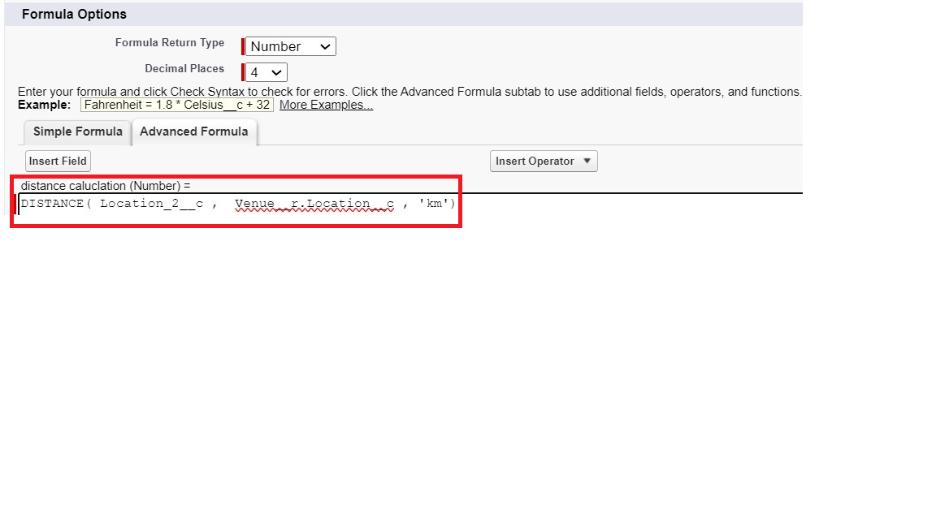

To create another fields in an object:

1. Go to setup >> click on Object Manager >> type object name(Drop-Off point) in search bar >> click on the object.
2. Now click on “Fields & Relationships” >> New
3. Select Data type as a “Picklist” and Click on Next
4. Fill the Above as following:

* Field Label : State
* Field Name : State
* Enter values, with each value separated by a new line :

Andhra Pradesh

Arunachal Pradesh

Assam

Bihar

Chhattisgarh

Goa

Gujarat

Haryana

Himachal Pradesh

Jharkhand

Karnataka

Kerala

Maharashtra

Madhya Pradesh

Manipur

Meghalaya

Mizoram

Nagaland

Odisha

Punjab

Rajasthan

Sikkim

Tamil Nadu

Tripura

Telangana

Uttar Pradesh

Uttarakhand

West Bengal

Andaman & Nicobar (UT)

Chandigarh (UT)

Dadra & Nagar Haveli and Daman & Diu (UT)

Delhi [National Capital Territory (NCT)]

Jammu & Kashmir (UT)

Ladakh (UT)

Lakshadweep (UT)

Puducherry (UT)

* Click on required check box
* Click on Next >> Next >> Save and new.

To create another fields in an object:

1. Go to setup >> click on Object Manager >> type object name(Task) in search bar >> click on the object.
2. Now click on “Fields & Relationships” >> New
3. Select Data type as a “Number” and Click on Next
4. Fill the Above as following:

* Field Label : Distance
* Field Name : Distance
* Length : 14
* Decimal Places : 4
* Click on required check box
* Click on Next >> Next >> Save and new.

**Activity 4 : Creation of fields for the Task object**

Go to setup>> click on Object Manager >> type object name(Task) in search bar >> click on the object.

2. Now click on “Fields & Relationships” >> New

3. Select Data type as a “Auto Number” and Click on Next

4. Fill the Above as following:

* Field Label : Task ID
* Display Format : TASK-{0}
* Starting Number : 1
* Field Name : gets auto generated
* Click on required check box
* Click on Next >> Next >> Save and new.

To create another fields in an object:

1. Go to setup >> click on Object Manager >> type object name(Task) in search bar >> click on the object.
2. Now click on “Fields & Relationships” >> New
3. Select Data type as a “Date” and Click on Next
4. Fill the Above as following:

* Field Label : Date
* Field Name : Date
* Click on required check box
* Click on Next >> Next >> Save and new.

To create another fields in an object:

1. Go to setup >> click on Object Manager >> type object name(Task) in search bar >> click on the object.
2. Now click on “Fields & Relationships” >> New
3. Select Data type as a “Picklist (Multi-Select)” and Click on Next
4. Fill the Above as following:

* Field Label : Food Category
* Field Name : Food Category
* Enter values, with each value separated by a new line :

Veg

Non-Veg

Salad

Snack

* Click on required check box
* Click on Next >> Next >> Save and new.

To create another fields in an object:

1. Go to setup >> click on Object Manager >> type object name(Task) in search bar >> click on the object.
2. Now click on “Fields & Relationships” >> New
3. Select Data type as a “Number” and Click on Next
4. Fill the Above as following:

* Field Label : Number of People Served
* Field Name : Number_of_People_Served
* Click on required check box
* Click on Next >> Next >> Save and new.

To create another fields in an object:

1. Go to setup >> click on Object Manager >> type object name(Task) in search bar >> click on the object.
2. Now click on “Fields & Relationships” >> New
3. Select Data type as a “Text” and Click on Next
4. Fill the Above as following:

* Field Label : Name of the Person
* Field Name : Name_of_the_Person
* Click on Next >> Next >> Save and new.

To create another fields in an object:

1. Go to setup>> click on Object Manager >> type object name(Task) in search bar >> click on the object.
2. Now click on “Fields & Relationships” >> New
3. Select Data type as a “Phone” and Click on Next
4. Fill the Above as following:

* Field Label : Phone
* Field Name : Phone
* Click on Next >> Next>> Save and new.

To create another fields in an object:

1. Go to setup >> click on Object Manager >> type object name(Task) in search bar >> click on the object.
2. Now click on “Fields & Relationships” >> New
3. Select Data type as a “Pick List” and Click on Next
4. Fill the Above as following:

* Field Label : Rating
* Field Name : Rating
* Enter values, with each value separated by a new line :

1

2

3

4

5

* Click on Next >> Next >> Save and new.

To create another fields in an object:

1. Go to setup >> click on Object Manager >> type object name(Task) in search bar >> click on the object.
2. Now click on “Fields & Relationships” >> New
3. Select Data type as a “Long Text Area” and Click on Next
4. Fill the Above as following:

* Field Label : Feedback
* Field Name : Feedback
* Click on Next >> Next >> Save and new.

**Activity 5 : Creation of fields for the Volunteer object**

1. Go to setup >> click on Object Manager >> type object name(Volunteer) in search bar >> click on the object.

2. Now click on “Fields & Relationships” >> New

3. Select Data type as a “Auto Number” and Click on Next

4. Fill the Above as following:

* Field Label : Volunteer ID
* Field Name : gets auto generated
* Click on required check box
* Click on Next >> Next >> Save and new.
* Click on Next >> Next >> Save and new.

To create another fields in an object:

1. Go to setup >> click on Object Manager >> type object name(Volunteer) in search bar >> click on the object.
2. Now click on “Fields & Relationships” >> New
3. Select Data type as a “Picklist” and Click on Next
4. Fill the Above as following:

* Field Label : Gender
* Field Name : Gender
* Enter values, with each value separated by a new line :

Female

Male

* Click on Next >> Next >> Save and new.

To create another fields in an object:

1. Go to setup >> click on Object Manager >> type object name(Volunteer) in search bar >> click on the object.
2. Now click on “Fields & Relationships” >> New
3. Select Data type as a “Date” and Click on Next
4. Fill the Above as following:

* Field Label : Available On
* Field Name : Available On
* Click on required check box
* Click on Next >> Next >> Save and new.

To create another fields in an object:

1. Go to setup >> click on Object Manager >> type object name(Volunteer) in search bar >> click on the object.
2. Now click on “Fields & Relationships” >> New
3. Select Data type as a “Number” and Click on Next
4. Fill the Above as following:

* Field Label : Age
* Field Name : Age
* Click on required check box
* Click on Next >> Next>> Save and new.

To create another fields in an object:

1. Go to setup >> click on Object Manager >> type object name(Volunteer) in search bar >> click on the object.
2. Now click on “Fields & Relationships” >> New
3. Select Data type as a “Email” and Click on Next
4. Fill the Above as following:

* Field Label : Email
* Field Name : Email
* Click on required check box
* Click on Next>> Next >> Save and new.

To create another fields in an object:

1. Go to setup >> click on Object Manager >> type object name(Volunteer) in search bar >> click on the object.
2. Now click on “Fields & Relationships” >> New
3. Select Data type as a “Number” and Click on Next
4. Fill the Above as following:

* Field Label : Contact Number
* Field Name : Contact_Number
* Click on required check box
* Click on Next >> Next >> Save and new.

To create another fields in an object:

1. Go to setup >> click on Object Manager >> type object name(Volunteer) in search bar >> click on the object.
2. Now click on “Fields & Relationships” >> New
3. Select Data type as a “Text Area (Long)” and Click on Next
4. Fill the Above as following:

* Field Label : Address
* Field Name : Address
* Click on Next >> Next >> Save and new.

To create another fields in an object:

1. Go to setup >> click on Object Manager >> type object name(Volunteer) in search bar >> click on the object.
2. Now click on “Fields & Relationships” >> New
3. Select Data type as a “Date” and Click on Next
4. Fill the Above as following:

* Field Label : Date of Birth
* Field Name : Date_of_Birth
* Click on Next >> Next >> Save and new.

### Activity 6 : Creation of fields for the Execution Details object

1.Go to setup >> click on Object Manager >> type object name(Volunteer) in search bar >> click on the object.

2. Now click on “Fields & Relationships” >> New

3. Select Data type as a “Auto Number” and Click on Next

4. Fill the Above as following:

* Field Label : Execution ID
* Field Name : gets auto generated
* Click on required check box
* Click on Next >> Next >> Save and new.

### Milestone 6 : FLOWS

### Activity 1 : Create Flow to create a record in Venue object

1. Go to setup >> type Flow in quick find box >> Click on the Flow and Select the New Flow.
2. Select the Screen flow. Click on create.

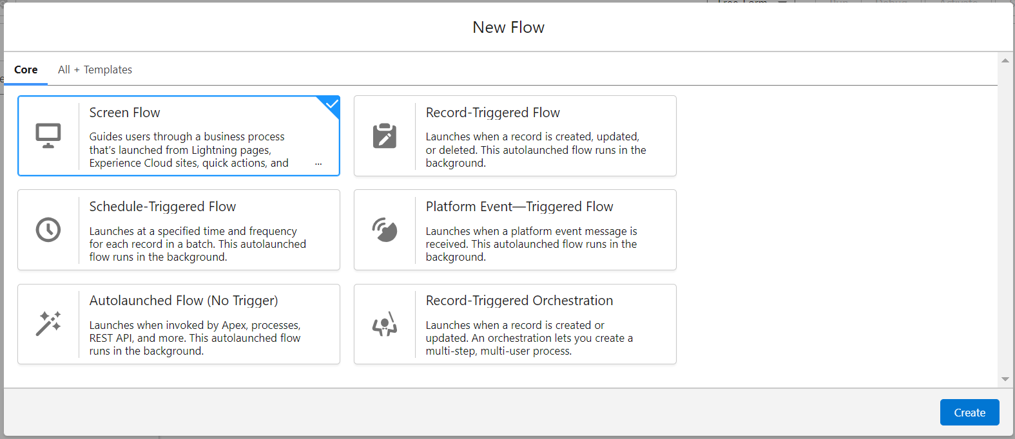

1. Click on the ‘+’ icon in between start and end, and click on screen element.
2. Under the Screen Properties:

Label : Venue Details

API Name : Venue_Details

1. Now lets add components in this flow. Click on Text Component and name it as:

Label : Venue Name

API Name : Venue_Name

1. Click on Email Component and name it as:

Label : Email

API Name : Contact_Email

1. Click on Phone Component and name it as:

Label : Phone

API Name : Contact_Phone

1. Click on Text Component and name it as:

Label : Venue Location

API Name : Venue_Location

1. Click on Number Component and name it as:

Label : Latitude

API Name : Latitude

1. Click on Number Component and name it as:

Label : longitude

API Name : longitude

1. Next click on Done. This would like below

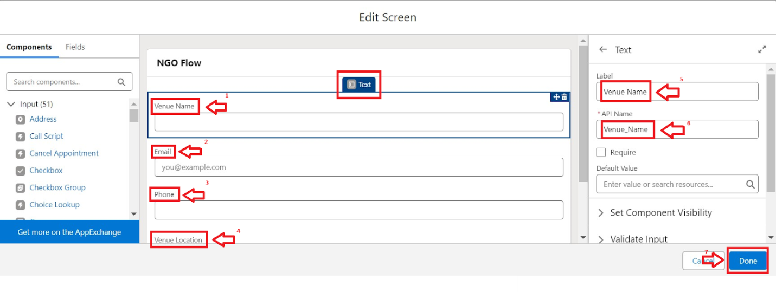

1. Click on the ‘+’ icon in between Venue details and end, and click on create record element.
2. Now label it as

Label : Create Venue Record

API Name : Create_Venue_Record

How Many Records to Create : One

How to Set the Record Fields : Use separate resources, and literal values

Object : Venue

Set Field Values for the Venue : Click on ‘Add Field’ 5 times

Field : Value = Contact_Email__c : {!Contact_Email.value}

Field : Value = Contact_Phone__c : {!Contact_Phone.value}

Field : Value = Name : {!Venue_Name}

Field : Value = Venue_Location__c : {!location}

Field : Value = Location__Latitude__s : {!latitude}

Field : Value = Location__Longitude__s : {!longitude}

1. This would look like:

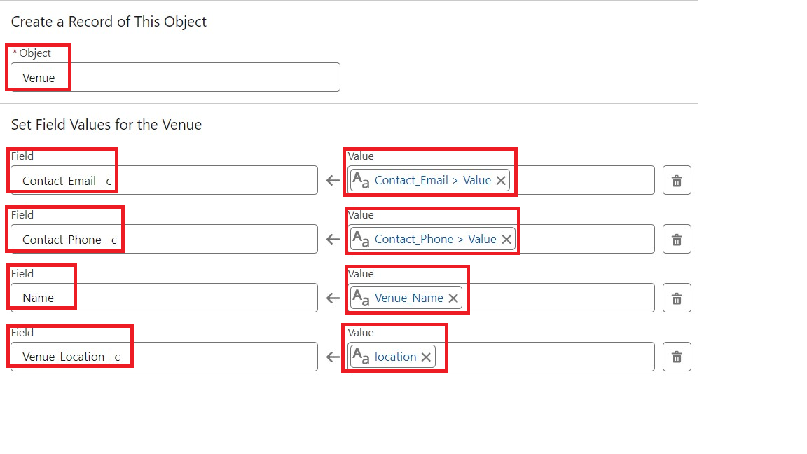

1. Click on Save as:

Flow Label : Venue Form

Flow API Name : Venue_Form

### Milestone 7 : Trigger

### Activity 1 : Create a Trigger

1. Log into the trailhead account, navigate to the gear icon in the top right corner.
2. Click on developer console and you will be navigated to a new console window.
3. Click on the File menu in the toolbar, and click on new >> Trigger.
4. Enter the trigger name and the object to be triggered.

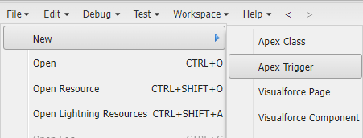

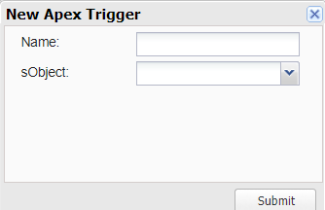

1. Enter Name : DropOffTrigger

sObject: Drop-Off Point

1. Click on Submit.

### Activity 2 : Trigger Code

(This Trigger is to assign Distance field to the Distance Calculation field. So that we can assign the distance in the sharing rules.)

**Code:**

trigger DropOffTrigger on Drop_Off_point__c (before insert) {

    for(Drop_Off_point__c Drop : Trigger.new){

        Drop.Distance__c = Drop.distance_calculation__c;

    }

}

### Milestone 8 : Profiles

1. Go to setup page >> type Profiles in Quick Find bar >> click on Profiles >> click on ‘S’
2. Click on Clone beside Standard Platform User.
3. Under Clone Profile:

Profile Name : NGOs Profile

1. Then click on Save

### Milestone 9 : Creation of Users

In our Project we consider them as NGO’s

### Activity 1 : Creation of User1

1. Go to setup page >> type users in Quick Find bar >> click on users>> New user.
2. In General Information give details as: (Note : create users as per your wish NGO’s)

First Name : Iksha Foundation

Last Name : Iksha_Foundation

Alias : iiksh

Email : Give Your Email

Username : [ikshafoundation@sb.com](mailto:ikshafoundation@sb.com) (give the username different)

Nickname : Auto Populated

User License : Salesforce Platform

Profile : NGOs Profile

Active : Check

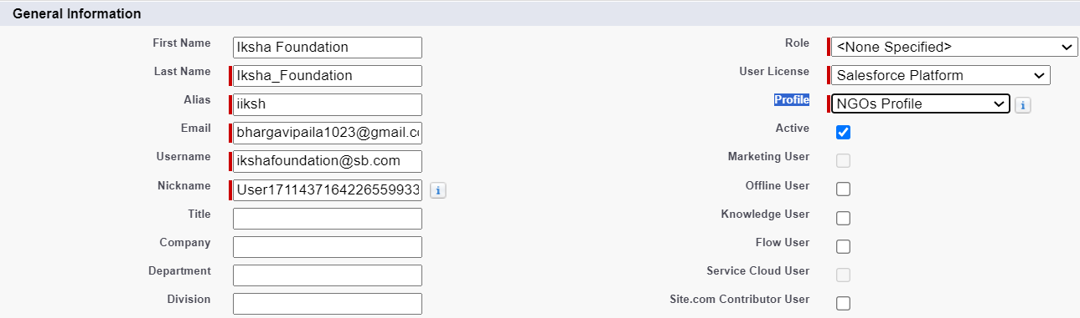

1. Click on Save

### Activity 2 : Creation of User2, User3

1. Create another Two Users by following steps in Activity - 1 with similar User License and Profile.
2. Give Different First Name, Last Name based on Different NGO’s.



### Milestone 10 : Public Groups

### Activity 1 : Creation of Public Group 1

1. Go to setup page  >>  type Public Groups in Quick Find bar  >>  click on Public Groups >>  click on New.
2. Under Group Information:

Label : Iksha

Group Name : Iksha

Grant Access Using Hierarchies : Check

1. In Search, Select Users.
2. In Selected Members Add Iksha Foundation and System Administrator

### Activity 2 : Creation of Public Group 2

1. By Following Steps in Activity 1, Create other  two Public Groups for other two users.
2. After Saving this would look like this.

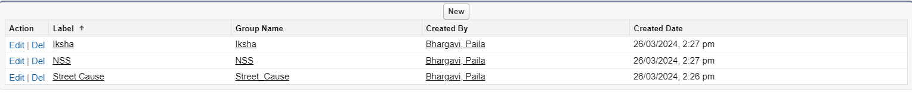

### Milestone 11 :Report Types

### Activity 1 : Creation of Report Types

1. Go to setup page  >>  type Report Types in Quick Find bar  >> click on Report Types  >>  click on Continue   >>  Click on New Custom Report Type.
2. In Define the Custom Report Type:

Primary Object : Select Venues

Report Type Label : Venue with DropOff with Volunteer

Report Type Name : Venue_with_DropOff_with_Volunteer

Description : Venue with DropOff with Volunteer

Store in Category : Select Other Reports

Deployment Status : Deployed

1. Click on Next
2. Near Click to relate another Object Select Drop-Off Points.
3. And also select "A" records may or may not have related "B" records.
4. Now again Near Click to relate another Object Select Volunteers.
5. Now click on Save.

### Milestone 12 : Reports

**Activity 1 : Creation of Report on Venue with DropOff with Volunteer**

1. Go to the app(FoodConnect)  >>  click on the reports tab
2. Click on New Folder.

Folder Label : Custom Reports

Folder Unique Name : CustomReports

1. Open Custom Reports and click on New Report
2. Select Report Type : Venue with DropOff with Volunteer
3. Then click on Start Report.
4. In GROUP ROWS : Add Volunteer Name
5. In Columns : Add Venue Name, Drop-Off point Name, Distance.

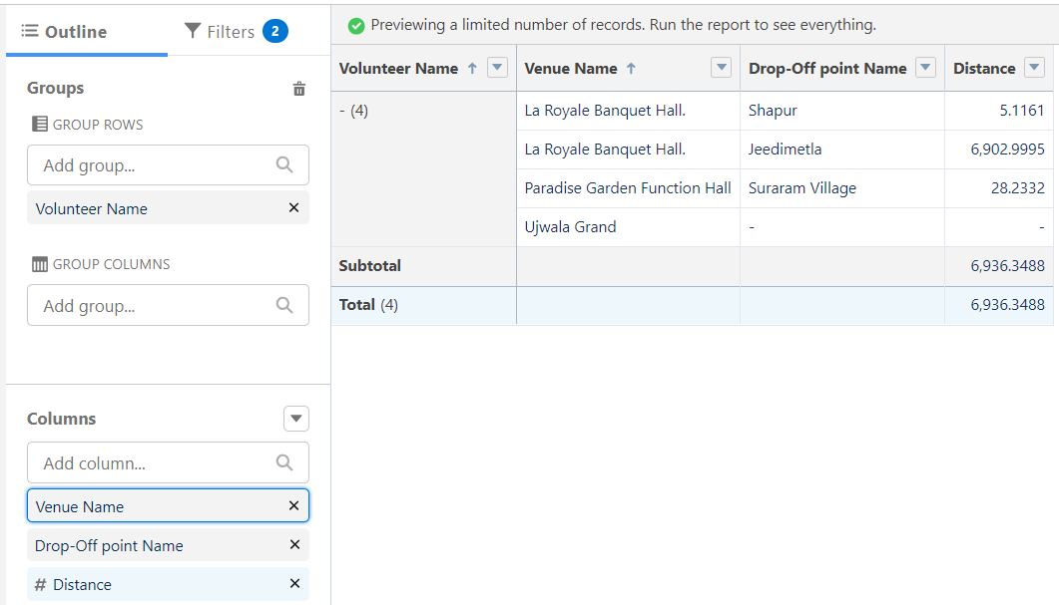

1. Now click on Save & Run.
2. Give Label as :
3. Report Name : venue and Drop Off point
4. Report Unique Name : Auto Populated
5. Click on Select Folder and select Custom Report, then click on Save.

**Activity 2 : Creation of Report on Volunteers with Execution Details and Tasks**

1. Go to the app(FoodConnect)  >>  click on the reports tab
2. Click on Custom Reports Folder and click on New Report
3. Select Report Type : Volunteers with Execution Details and Tasks.
4. Then click on Start Report.
5. In GROUP ROWS : Volunteer ID
6. In Columns : Add Volunteer : Volunteer Name, Task : Task Name, Execution Detail : Execution Detail Name, Volunteer: Owner Name, Task: Date, Task : Rating.

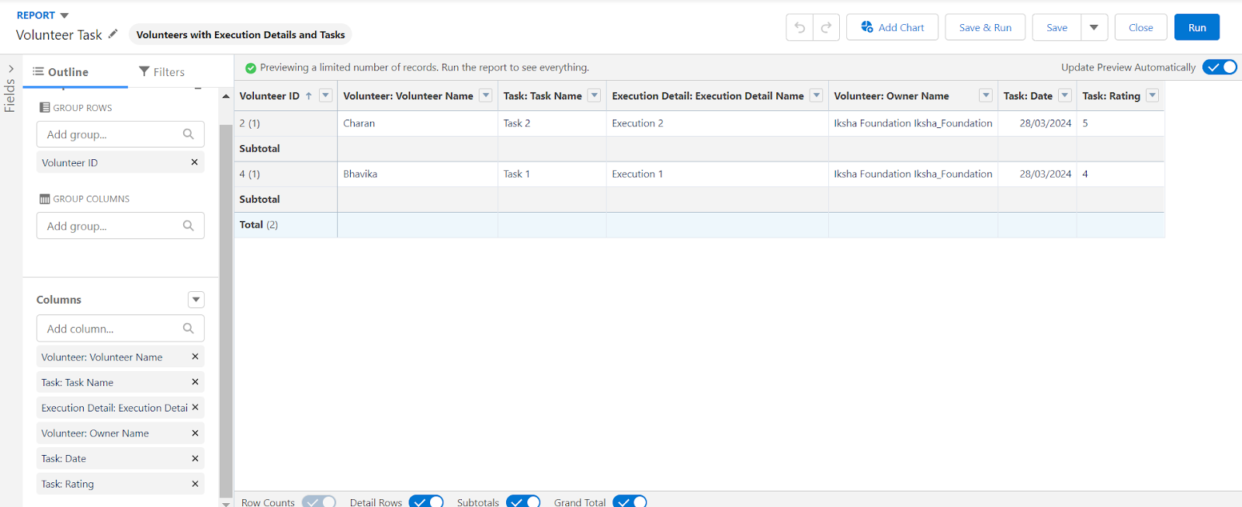

1. Now click on Save & Run.
2. Give Label as :

Report Name : Volunteer Task

Report Unique Name : Auto Populated

1. Click on Select Folder and select Custom Report, then click on Save.

### Milestone 13 : Dashboards

### Activity 1 : Adding venue and Drop Off point Report to the Dashboard

1. Go to the app(FoodConnect)  >>  click on the Dashboards tab.
2. Click on New Folder.

Folder Label : Custom Dashboards

Folder Unique Name : Auto Populated

1. Open Custom Dashboards and click on New Dashboards
2. Name : Organization Details
3. Click on Widget and select Chart or Table
4. In Select Report : Select venue and Drop Off point Report.
5. Then click on select
6. In Add Component:

Display As : Select Lightning Table

Component Theme : Select Dark (Optional)

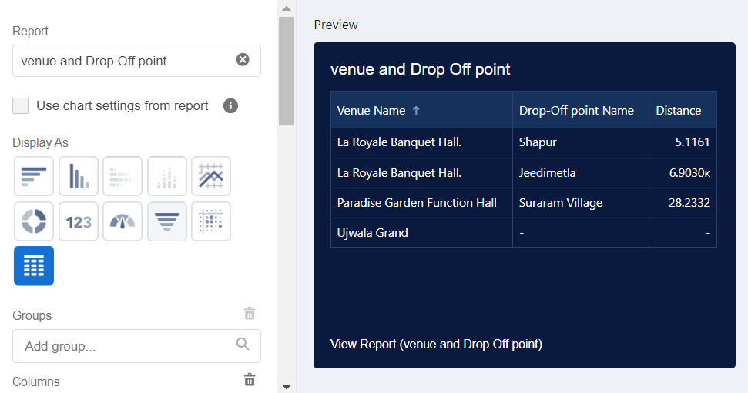

1. Now click on save.

### Activity 2 : Adding Volunteer Task Report to the Dashboard

1. Click on Widget and select Chart or Table
2. In Select Report : Select Volunteer Task Report.
3. Then click on select
4. In Add Component:

Display As : Select Line Chart

Component Theme : Select Dark (Optional)

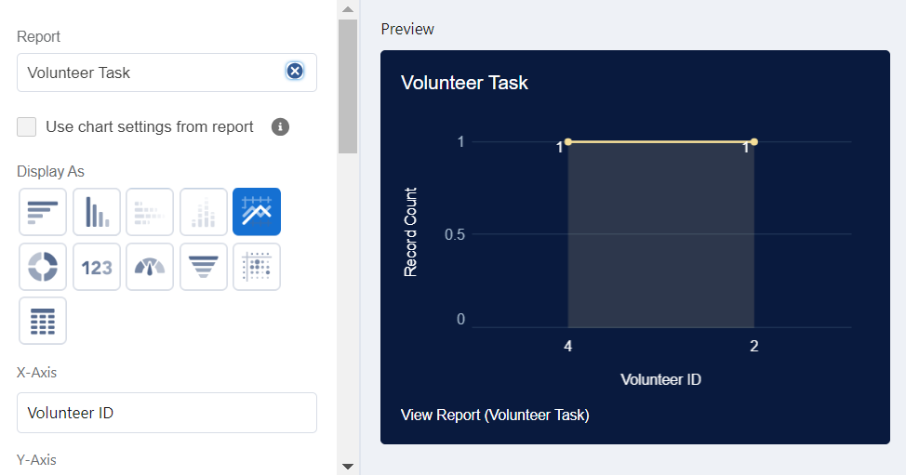

1. Now click on save.

### Activity 3 : Adding a Picture to the Dashboard (Optional)

(Note : To upload an image into the Dashboard, we have to first download an image from google or other sources into your system)

1. Click on Widget and select Image. Then click on Browse Files.
2. Then Select the Picture you want to upload in this Dashboard.
3. Then click on Save As :

Name : Task Execution Details

Click on Select Folder and select Custom Dashboards

1. Click on Select Folder and then Save.

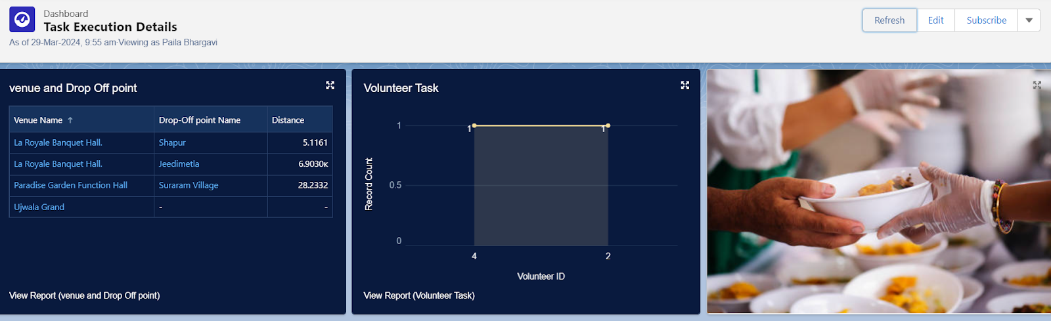

### Milestone 14 : Sharing Rules

**Activity 1 : Creation of sharing rules**

1. Go to setup  >>  type Sharing Settings in quick find box  >>  Click on the Sharing Settings.
2. Scroll down and find Drop-Off point Sharing Rules.
3. Click on new near Drop-Off point Sharing Rules and Name it as:

Label : Rule 1

Rule Name : Rule_1

1. Select your rule type : Select Based on criteria.
2. Select which records to be shared:

Field : Operator : Value = Distance : less than : 15

1. Select the users to share with : Near Share With

Public Groups : Iksha

1. Click on Save.
2. Click on new near Drop-Off point Sharing Rules and Name it as:

Label : Rule 2

Rule Name : Rule_2

1. Select your rule type : Select Based on criteria.
2. Select which records to be shared:

Field : Operator : Value = Distance : greater than : 15

Field : Operator : Value = Distance : less or equal : 30

1. Select the users to share with : Near Share With

Public Groups : NSS

1. Click on Save.
2. Click on new near Drop-Off point Sharing Rules and Name it as:

Label : Rule 3

Rule Name : Rule_3

1. Select your rule type : Select Based on criteria.
2. Select which records to be shared:

Field : Operator : Value = Distance : greater than : 30

Field : Operator : Value = Distance : less or equal : 50

1. Select the users to share with : Near Share With

Public Groups : Street Cause

1. Click on Save.

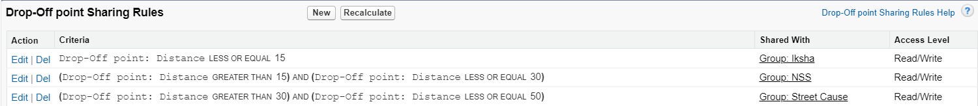

### Milestone 15 : Home Page

### Activity 1 : Creation of Home Page

1. Go to setup >> type Lightning App Builder in quick find box  >>  Click on the Lightning App Builder and Select the New.
2. Select Home Page and give Label as HOME Page.
3. Select Standard Home Page.
4. Near Components search for Flow and Drag and Drop in Right Side Section..
5. On the right hand side:

Flow : Venue Flow

1. Near Components search for Dashboard, then Drag and Drop it in first Section.

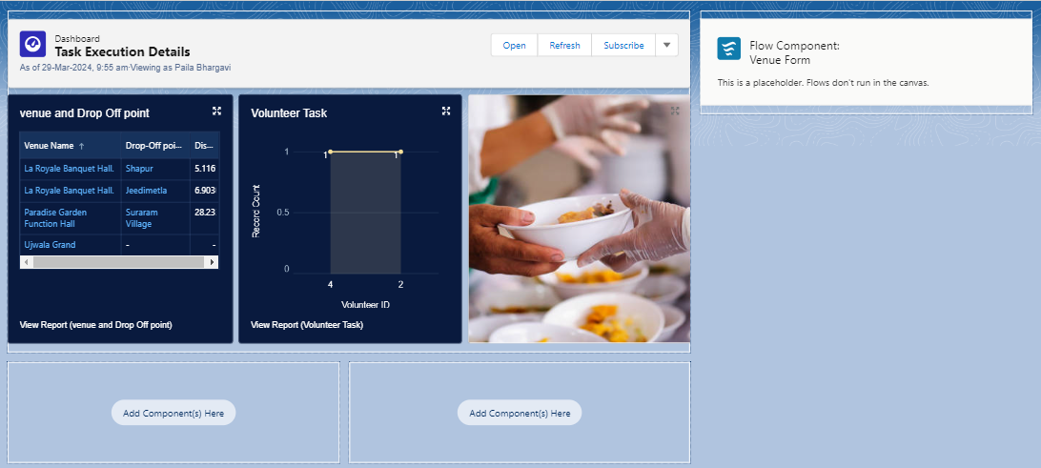

1. Click on Save and Activation, then click on App Default, then Add Assignments.
2. Add FoodConnect App and then Save.
3. FoodConnect Home Page would Look Like this.

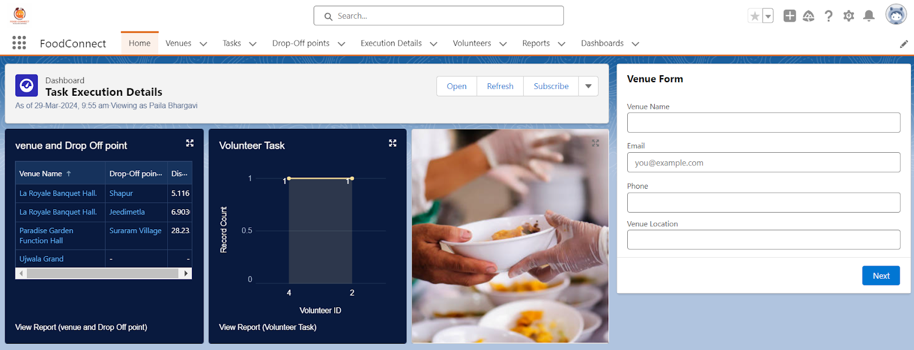

### Conclusion

By leveraging the Salesforce platform, the project successfully established a streamlined and transparent system for managing surplus food donations. Through efficient coordination with volunteers and timely delivery to beneficiaries, the project effectively addressed food insecurity while maximizing the utilization of available resources

**Future Scope**

1.Technology Integration

* Development of a mobile app or website to connect donors (restaurants, hostels, events, households) with NGOs/volunteers in real-time.
* Use of AI & IoT to track food freshness, expiry, and logistics for safe distribution.

2.Collaboration & Partnerships

* Tie-ups with restaurants, hotels, marriage halls, corporates, hostels, and supermarkets to ensure a consistent food supply.
* Partnerships with government agencies and NGOs for large-scale outreach.

3. Logistics & Distribution

* Establishing cold storage vans and efficient delivery networks to maintain food safety.
* Setting up community fridges in cities for easy access by needy people.

4. Awareness & Social Impact

* Conduct campaigns to reduce food wastage and encourage people to donate surplus food.
* Recognition programs for regular contributors (certificates, tax benefits, CSR credits).

5. Scalability & Expansion

* Expansion from local communities to statewide and nationwide networks.
* International collaborations with food banks and global NGOs (like Feeding India, Robin Hood Army).

6. Sustainability & Innovation

* Convert inedible leftovers into compost or animal feed to ensure zero waste.
* Encourage sustainable food packaging for donations.

7. Government & Policy Support

* Lobby for food donation laws that protect donors from liability.
* Inclusion of the project under CSR (Corporate Social Responsibility) to attract funding.